Educational Online Community Analysis
Mr. Patrick Holness, Mr. Manuel F. Negron
New Jersey City University

Community Analysis
edWeb is a free professional learning network that hosts online communities and engaging edWebinars for educators at all times and is focused on the needs of all educators. “Social networks can be used to provide educators with career-long personal learning tools and resources that make professional learning timely and relevant as well as an ongoing activity that continually improves practice and evolves their skills over time.” (National Education Technology Plan, 2010). Membership is free due to various partnerships and sponsorships that help them host and present programs on a vast range of topics. edWeb was founded 11 years ago in 2008 and includes teachers, librarians, and administrators who are passionate and generous in sharing the most innovative and effective ideas that can improve their own practice, but more importantly, student learning and preparation for college, career and life (Schmucki, L, 2018). Educators and institutions can use this community to create personal learning networks to collaborate, share ideas, and new initiatives.
EdWeb.net is a representation of a community of practice as their sole objective and priorities are shared by the community (Wenger, et al., 2009) .This community currently has 500,000 members worldwide and 300,000 additional educators who have registered and/or attended edWebinars. EdWeb anticipates growing to five million members within the next decade. Community members are passionate about connecting with peers and learning new ideas to improve teaching and learning. EdWeb hosts 300 webinars a year, striving to provide authentic engagement for educators globally through shared collaborations and interactions so that members become leaders and experts in their communities (Wenger, E., 1998). Most members join one or more professional learning communities and attend edWebinars live or on-demand. The edWebinars are being recognized for state-level approval for teacher re-licensure.
What is the Organization Seeking to Accomplish?
EdWeb is a fast growing global community with 500,000 educators; 92% of them in the United States; representing 185 countries. edWeb reaches all preK-12 educators in all roles throughout the United States such as:
● Teachers
● Administrators
● Librarians
● Curriculum & Instruction
● College Faculty
● Instructional Technology
● Professional Development
● Assessment & Testing
● Technology Services
● New Teacher Instruction
● Student Services/Counseling
● Special Education/Needs
● Early Childhood Education
Community members are passionate about connecting with peers and learning new ideas to improve teaching and learning. EdWeb anticipates growing to five million members within the next decade. According to Lisa Schmucki, CEO & Founder of EdWeb.net, the online network strives to “continue to grow and do what we do”, as well as ensuring we can scale as we grow.
The community also plans to get more state approvals and adoption of edWeb by schools, districts, and states as well as continuing to have the edWeb platform and professional learning be free, but add additional new member services such as job boards and coaching/training on professional learning for schools/districts
EdWeb reflects a profitable business model that represents a win-win solution for professional learning . Educators join online communities, attend engaging edWebinars, and earn CE certificates. EdWeb online communities cover a vast range of preK-12 topics. Educators earn professional development hours with edWeb. EdWeb is also state approved for teacher relicensure in New York, Massachusetts, Pennsylvania, Texas, Arkansas, Kentucky, and Utah. EdWeb certificates are also used nationwide for professional development hours.
According to a 2018 professional learning survey conducted, approximately 45% of the community members are getting professional development credit for the edWebinars from their schools, district, and/or state and 85% percent of the members state that they acquire valuable information and resources.
EdWeb has also been recognized as a 2018 SIIA CODie winner in the following categories:
● Best overall education solution
● Best collaborative social media solution for educators
● Best professional learning solution for faculty and administrative staff

Sixty articles on edWebinars have also been published in 2018 in eSchool News and edscoop.
Goal Attainment
With constant budget cuts and underfunding in education, school leaders must find ways to ensure that teachers receive professional learning. Professional learning is viewed as an important strategy to teach students the skills they require in the 21st century. Today’s teachers must employ more sophisticated forms of pedagogy so students can learn to problem solve, master challenging content, collaborate, and develop effective communication (Darling-Hammond, Hyler, & Gardner, 2017). There is research that suggests that one-time professional development is ineffective and not budget friendly. The goal of edWeb is to provide a free social network that provides educators with the personalized professional learning and collaboration needed to improve teaching and learning (Lisa Schmucki, personal communication, March 4, 2019). Educators are able to participate in edWebinars, online communities, and have opportunities to earn CE certificates. These are the ways that edWeb ensures that they are accomplishing their goals.
The net free live edWebinars that are available to its membership hold about seven a week. The data shows that there is an average of 8,500 registrations per webinar, 3,800 average live attendees per webinar, and 3,100 average on-demand views (Lisa Schmucki, personal communication, March 4, 2019). Sponsors and partners recruit the outstanding educators that present the edWebinars. Over 1,400 experts and innovators present the edWebinars. In the Monumental Guide to Building Online Communities the guide unambiguously state, “you absolutely cannot expect to build a vibrant, sustainable online community without valuable content” (Mack Web Solutions, n.d., Chapter 2).
There are over 40 plus communities that cover a variety of preK-12 topics this does not include topics related specifically to administration. Members have the ability to join those communities that meet their individual needs. New members are asked a series of questions to help meet their needs. In this case edWeb has designed its community to accommodate for newcomers making it easy for them to join the best fit communities (Kraut & Resnick, 2011). “Communities host 300 live edWebinars per year resulting in over 1,500 recordings available on-demand” (Lisa Schmucki, personal communication, March 4, 2019). Ms. Schmucki explained that educators have the ability to earn professional development certificates. Data from the edWeb 2018 Professional Learning Survey reveals that there is growth in the number of people receiving PD credit for edWebinars. The Monumental Guide to Building Online Communities further explains that valuable content demonstrates that “you know what you are talking about,” you care about your memberships specific needs, and your content is worth sharing and revisiting (Mack Web Solutions, n.d.).
In order for edWeb to be successful sustaining and growing membership is important. edWeb has reached 500,000 educators 92% are from the United States with a reach in 185 countries. edWeb 2018 Professional Learning Survey question “How likely are you to recommend edWeb to a colleague” the data increased from 69% in 2016 to 80% in 2018 (Lisa Schmucki, personal communication, March 4, 2019). The data indicates that people who are committed to an organization tend to be more satisfied and are less likely to leave (Kraut & Resnick, 2011).
Data and Matrix
Data is essential in managing your online community. Community leaders have to identify what data to collect and this data should be in line with the communities’ goals. Simply collecting data can become meaningless if you are not tracking the right thing (Mack Web Solutions, n.d.). The Monumental Guide to Building Online Communities calls it “two streams, one river” data can be collected with the use of sophisticated software or you can simply survey your members (Mack Web Solutions, n.d., Chapter 3). Ms. Schmucki follows the approach of the latter.
Ms. Schmucki’s background in education and business lends itself to her laser focus on how educators connect and collaborate using edWeb social network and edWebinars to provide free professional learning (personal communication, March 4, 2019). “We’ve been conducting research on educators’ use of social media and its impact on professional learning for a number of years to track how technology is impacting professional learning and to continuously improve edWeb” (Lisa Schmucki, personal communication, March 4, 2019). In 2016 and 2018 edWeb surveyed its teacher members and found:
The top reasons why teachers engage in professional learning is to improve learning for their students, to help improve their own teaching, and because they enjoy learning new ideas and practices from peers and experts in their field. These results reflect the dedication of teachers to the goal of professional learning – to have an impact on student learning – and also show how collaboration with peers makes professional learning enjoyable (Lisa Schmucki, personal communication, March 4, 2019).
The 2018 Professional Learning Survey showed similarities between administrators and teachers both 47% and 46% respectively indicating that the edWebinars were the most beneficial type of professional learning. 2018 survey respondents indicated more positive responses about edWeb in 2018 than in 2016 (Lisa Schmucki, personal communication, March 4, 2019). Ms. Schmucki also shared that in 2017 the Cambridge Learning Group completed an edWeb.net Case Study: Rock Valley Community School District (Iowa). It was determined that edWeb embodies the four features of educational research characterizing high quality professional learning experiences, best practices for integrating informal inline professional learning with formal district professional development, and the effective design of online communities for teachers. edWeb provides the support that Rock Valley leaders need to implement research-based practices (Lisa Schmucki , personal communication, March 4, 2019).
Based on the data matrix edWeb is inline with the National Education Technology Plan to transform education in America. Through Goal 3.0 Teaching: Prepare and Connect “professional educators will be supported individually and in teams by technology that connects them to data, content, resources, expertise, and learning experiences that enable and inspire more effective teaching for all learners” (U.S. Department of Education, 2010, p. xviii). Specifically 3.2 Leverage social networking technologies, which lead to life long learning opportunities across time, space and location.
Conclusion
In an age of budget cuts and underfunding in education school leaders must find ways to ensure that teachers receive professional learning. Professional learning is viewed as an important strategy to teach students the skills they require in the 21st century. Today’s teachers must employ more sophisticated forms of pedagogy so students can learn to problem solve, master challenging content, collaborate, and develop effective communication (Darling-Hammond, Hyler, & Gardner, 2017). There is research that suggests that one-time professional development is ineffective and not budget friendly. edWeb provides educators with researched support coupled with social networking to improve teaching and learning. This approach to learning takes educators from a silo approach to teaching to a collaborative approach.
Policy maker’s call for educators to use research based practices to improve teaching in order to improve student achievement. Based on the data matrix edWeb is inline with the National Education Technology Plan to transform education in America. Through Goal 3.0 Teaching: Prepare and Connect “professional educators will be supported individually and in teams by technology that connects them to data, content, resources, expertise, and learning experiences that enable and inspire more effective teaching for all learners” (U.S. Department of Education, 2010, p. xviii). Specifically 3.2 Leverage social networking technologies, which will lead to lifelong learning opportunities across time, space and location.
In an era of high stakes testing and accountability edWeb is situated and can assist to improve teaching and learning in rural areas and areas that serve underserved populations. Ms. Schmucki pointed out that there is higher than average penetration in urban/rural and higher poverty areas (personal communication, March 4, 2019). The data indicated that based on the 2010 U.S. Census Data there are more edWeb members than Teacher Universe members in both the highest and lowest populations’ index.

Collaboration
Through true collaboration, we created a WhatsApp group and began our discussion on our strategies to complete this assessment along with multiple phone conversations. As stated in the directions, we found this assessment to be challenging as many educational online communities that we reached out did not respond or were not willing to participate. Our roles were as follows:
Manny:
● Contacted various communities
● Contacted the CEO and Founder of EdWeb.net
● Opened a shared Google doc for the start of assessment two
● Led part one and two of the assignment
● Added and edited content
Patrick:
● Contacted various communities
● Contacted the CEO and Founder of EdWeb.net
● Created additional interview questions for the interviewee
● Led part three and four of the assignment
● Added and edited content

References
Cator, K., & Duncan, A. (2010, November). https://www.ed.gov/Transforming American Education, Learning Powered by Technology. Retrieved March 10, 2019, from https://www.ed.gov/sites/default/files/netp2010.pdf
Darling-Hammond , L., Hyler, M. E., & Gardner, M. (2017). Effective Teacher Professional Develpment . Retrieved from https://learningpolicyinstitute.org/product/effective-teacher-professional-development-report
Kraut, R. E. & Resnick, P. (2011). Building successful online communities: Evidence-based
social design. Cambridge, Massachusetts, The MIT Press.
MackWebSolutions. (2013). The truly monumental guide to building online communities.
Retrieved on February 12, 2018 from: http://bit.ly/1cPGAWZ
Millington, R. (2011). The proven path: The most successful and reliable approach in the history
of building online communities. Retrieved on February 12, 2018 from:
http://www.feverbee.com/wp-content/uploads/2015/03/theprovenpath.pdf
Online Community Interview [Interview by L. Schumucki]. (2019, March 09).
U.S. Department of Education (2010). Transforming American education: learning powered by technology . , 1-124. Retrieved from https://www.ed.gov/sites/default/files/netp2010.pdf
Wenger, E. (1998). Communities of practice: Learning, meaning, and identity. New York, NY:
Cambridge University.
Wenger, E., & Trayner-Wenger, B. (2015). Communities of practice: a brief introduction. April
2015, 1–8. https://doi.org/10.2277/0521663636

Appendix A
Request for interview sent to community administrators:
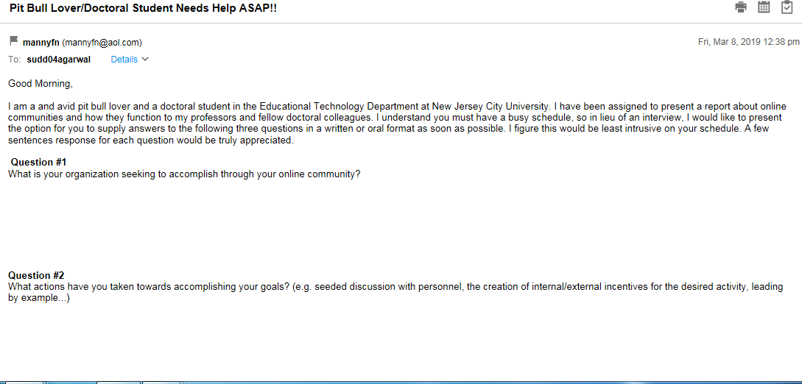
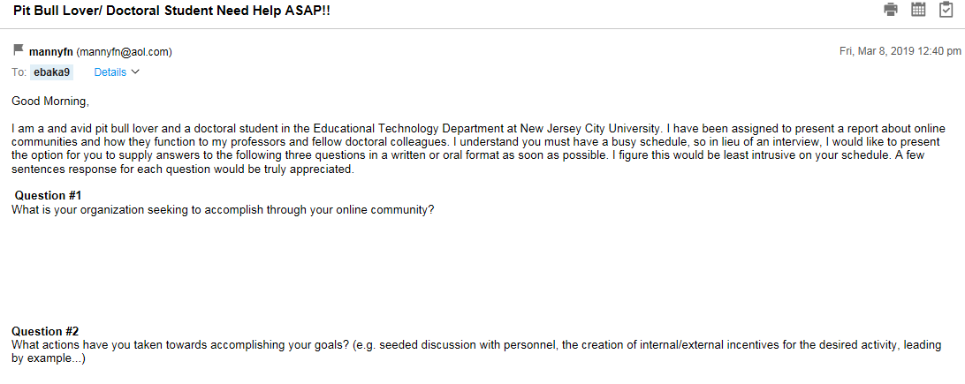
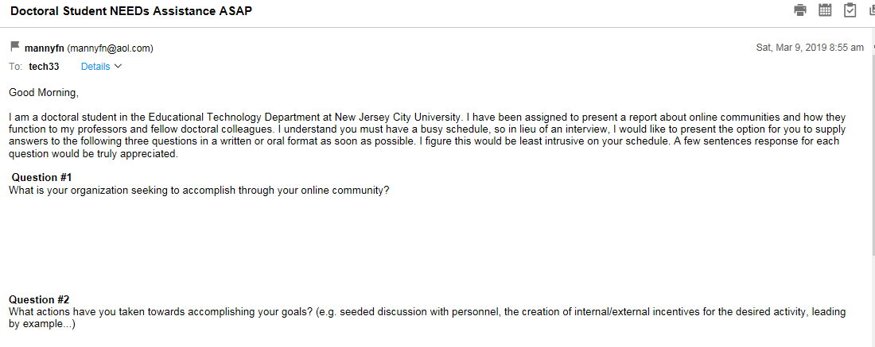
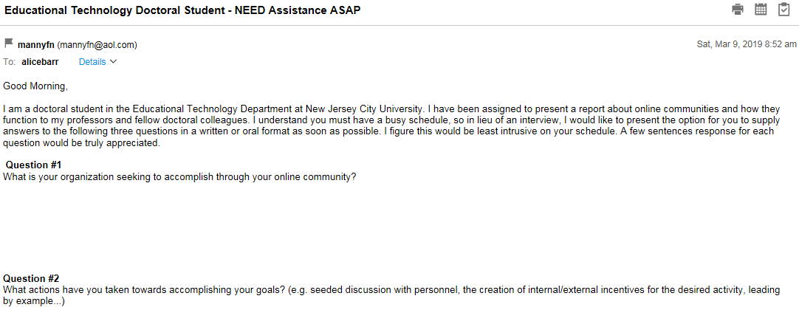
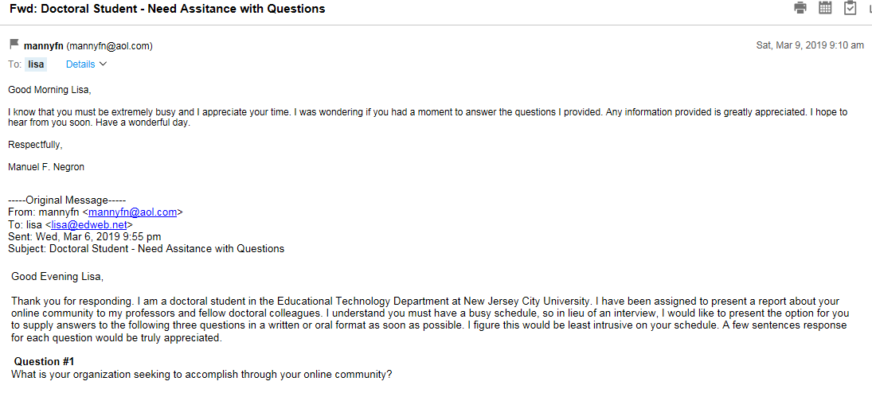
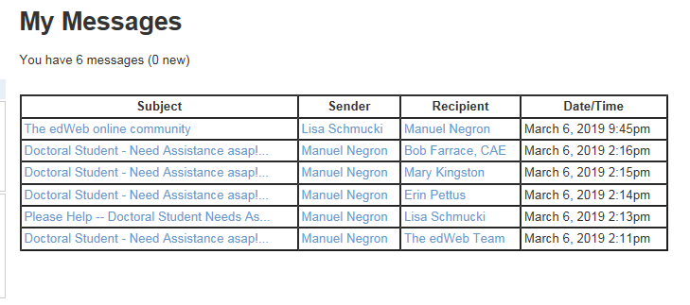

Appendix B
Response to interview questions from Ms.Lisa Schmucki, CEO & Founder of EdWeb.net:
- What is the organization seeking to accomplish through their online community?
https://home.edweb.net/why-edweb/
https://home.edweb.net/edweb-celebrates-10-years/

- What actions have they taken towards accomplishing these goals?

https://www.dropbox.com/s/3lh6nh0awrtnp8j/edWeb_Overview%2019-0301.pdf?dl=0

- What metrics do they employ to understand their progress towards these goals? (e.g., issue turnaround time, customer satisfaction, external participant numbers, and activity, lurker-to leader conversion, speed/quality of question answering).
https://www.dropbox.com/s/3lh6nh0awrtnp8j/edWeb_Overview%2019-0301.pdf?dl=0

Surveys:
https://www.dropbox.com/s/39m1xd7qfpz372s/2019%20Professional%20Learning%20Survey%20Presentation-converted.pdf?dl=0

Research:
https://home.edweb.net/category/research/
Documenting Best Practices: https://home.edweb.net/tag/pd-stories/ … Plus, continuous feedback from the edWeb community.

Personal:

● What is your name?
● What is your job title and where do you work?
● What personal and professional interests led you to create edWeb?
● Are you involved in other organizations or innovations, as well?

Lisa Schmucki, Founder & CEO — Lisa developed the idea for edWeb 10 years ago when she saw how social networking technology could help educators connect and collaborate and break down the silos and traditional barriers that have existed in education. edWeb is now an award-winning global professional learning network that helps educators connect and collaborate online to make learning more engaging, supportive, and effective for all students. edWeb is free for all educators (teachers, librarians, administrators) thanks to the sponsorship of leading education companies and non-profit organizations. Lisa is an education industry executive with more than 30 years experience in marketing, product management, and product development. She is a member of the Board of the SIIA Education Technology Industry Association (ETIN). She is a graduate of Princeton University and has a Masters Degree from the Stern School of Business at NYU.

● How has your personal experience shaped your role as founder/CEO?

https://home.edweb.net/edweb-celebrates-10-years/

Organizational

● Please provide a brief history of your organization.

See links above

● In your opinion what makes edWeb a stand alone community for educators?
From our research, we think we are the largest social network dedicated to free global networking, collaboration, and professional learning for educators at all levels. The sponsor support we have garnered make us a self-sustaining, and thus sustainable network.
We also seem to be the only community of its kind that offers credit to a large % of our community for their school, district, and state professional development hours.

● How is membership obtained for edWeb?

Professionals involved in education or individuals with an interest in education are eligible to join edWeb.net. A professional involved in education includes any individual who is employed by an organization that is involved in education including an educational institution, a library, a non-profit organization, a research organization, a company, an association, a government agency or organization. An individual with an interest in education includes any individual who is a community leader, a parent, a retired educator, an education consultant, a student teacher or intern, a student in a teacher education program, a private teacher, or a tutor. Students who are 18 years of age or older, may use edWeb as part of a course taught by an educator. Students who are under 18 are allowed to watch our webinars as part of a class, but only under the supervision of a teacher, and are not allowed to join edWeb.net or log into any of our live webinars on their own. Use of edWeb.net by anyone else is not permitted. No one under 18 years of age is eligible to become a member of edWeb.net. edWeb.net is not responsible if an individual joins the site who is not eligible. Membership in edWeb.net is void where prohibited.

● What is your rationale for making it a public/private community?
From the beginning we knew that collaboration in a professional community needed to have both public and private optiong. Mark Zuckerberg has just realized this. We knew from the beginning.

● What interactions do you encourage within edWeb community? Group discussion, resource sharing, webinars etc. Explain and please give examples.
All of the above. We provide a variety of tools to support the needs of the community.

● What makes edWeb unique?

See above

Goals and Actions

● **What are your organization’s goals?

Continue to grow and do what we do.
Ensure we can scale as we grow.
Get more state approvals and adoption of edWeb by schools, districts, and states.
Continue to have the edWeb platform and professional learning be free, but add new member services:
- Job Board
- Coaching and training on professional learning for schools/districts
● **What actions has it taken toward accomplishing its goals? For example, creation of internal/external incentives for desired activity, leading by example...

See above

** What metrics do you employ to understand your progress towards these goals? (e.g., issue turnaround time, customer satisfaction, external participant numbers and activity, lurker-to leader conversion, speed/quality of question answering)

See above

● How large is edWeb (member count)

340,000 member worldwide + 300,000 additional educators who have registered and/or attended our edWebinars

● What kind of adaptations has the community gone through to meet the needs of its members? Are there any privacy concerns?

We go through continual adaptation and development to meet the needs of our members. It’s constant process.
Last year, we added personal edWebinar transcripts for our members that provide CE certificates customized for specific state requirements.

For privacy issues see:

https://home.edweb.net/privacy/

● What obstacles have you encountered with your online community and how did you overcome them?

We had to get to a certain size to have enough activity to interest educators, and enough educators to interest sponsors.
It has been critical to earn the trust of educators and sponsors. There is no substitute for that, and many organizations lose that along the way.

● Have you had any problems with members of the Group? Or members who spam your page/groups?

Not really, and we’ve been able to put controls in place to prevent it.

● Do members ever meet-up ?

We’d like to do that more. We’ve focused almost entirely on online collaboration.

● What if any other social media accounts is edWeb linked to?

We post on Twitter, Facebook, and LinkedIn.

● How do you use data measure the goals of edWeb?

This slide deck has what we share publicly:

https://www.dropbox.com/s/3lh6nh0awrtnp8j/edWeb_Overview%2019-0301.pdf?dl=0

● What data is the most important for tracking?

Our primary focus is on our edWebinars. We host 300 live presentations a year. Our attendance is up 50% over last year. We think that is the best measure of engagement.
Our on-demand views of our recorded edWebinars is also up significantly.
And with all this it means educators are earning more certificates.

● What data are you able to share?

See above.

● What’s in the future for edWeb?

See above

● Is there any other additional information you might like to share with us?

We’ve won some great awards:

https://home.edweb.net/awards-and-recognition/

Here are comments from educators:

https://home.edweb.net/testimonials-from-the-edweb-community/

