Statistical Analysis of English Language Arts and Math STAR Assessment Scores
Mr. Manuel F. Negron
New Jersey City University

Introduction
The STAR Renaissance Reading and Math assessments are computer adaptive assessments that provide educators with data on academic growth and achievement. The assessments provide an estimate of the student’s skills and compares their abilities to norms throughout the nation. Several school districts in New Jersey are currently using STAR assessments to determine possible outcomes on the New Jersey Student Learning Assessment (NJSLA), formerly known as the Partnership for Assessment and Readiness for College and Careers assessment, (PARCC). STAR assessment scores are aligned to the PARCC cut scores on five achievement levels.
Throughout this study, I will conduct an analysis of 2018-2019 third grade English Language Arts and Math STAR scores as variables to determine significant differences based on race and/or gender. The results of this analysis can provide educators with data and resources that assist in the development of effective instruction and curriculum. It also provides descriptive feedback about classroom, individual student, and grade level progress.
My hypothesis is as follows:
H0 There is no difference in the 2018-2019 English Language Arts or Math assessment STAR scores by race or gender.
H1 There is a difference in the2018-2019 English Language Arts or Math assessment STAR scores by race.
H2 There is a difference in the2018-2019 English Language Arts or Math assessment STAR scores by gender.

Data Sampling and Collection
For this study, I retrieved the 2018-2019 third grade Spring English Language Arts and Math STAR scores from the growth reports on the STAR Renaissance platform. I also retrieved the 2018-2019 third grade Fall English Language Arts and Math STAR scores to identify differences that may have occurred between the fall and spring. The nominal variables for this analysis are race and gender, while the scale variables are the STAR ELA and Math scores. The STAR Reading and Math assessment cut-score equivalents for third grade are as follows:
Reading
- Level 1 – (< 304) = Did Not Meet Expectations
- Level 2 – (304-412) = Partially Met Expectations
- Level 3 – (413-513) = Approached Expectations
- Level 4 – (514-923) = Met Expectations
- Level 5 – (> = 924) = Exceeded Expectations
Math
• Level 1 – (< 504) = Did not Meet Expectations
• Level 2 – (504-588) = Partially Met Expectations
• Level 3 – (589-648) = Approached Expectations
• Level 4 – (649-742) = Met Expectations
• Level 5 – (> = 743) = Exceeded Expectations

Description of Data
STAR English Language Arts and Math assessment scores of third grade students (n = 26) at the ABC public school were analyzed in this study. Using the SPSS software, I performed descriptive and inferential statistics on the data collected. According to Salkind (2017), descriptive statistics are values that summarize and describe traits of the data collected in a study. By using conducting descriptive statistics, I identified the measures of central tendency (mean, median, & mode) and the measures of dispersion (standard deviation, range, and variance). Inferential statistics were also conducted to make inferences between the groups. ANOVA was conducted to test for differences in the means between Hispanics and African Americans. The independent t-test was conducted to compare the means of males and females.
Descriptive Statistics
Figure 1, shown below displays the measures of central tendency for the third grade 2018-2019 Spring English Language Arts and Math STAR assessment scores. The mean of the third grade ELA scores is 411, median is 418, and multiple modes are identified with the smallest value of 101. The mean of the third grade Math scores is 614, median is 619, and multiple modes are identified with the smallest value of 616. The measures of dispersion for the ELA scores are; standard deviation 116, variance 13421, and the range is 559. The measures of dispersion for the Math scores are; standard deviation 64, variance 4148, and the range is 327. After analyzing this data, I have identified a significant difference of 203 when ELA mean scores are compared to Math. These statistics have also identified that according to the STAR Reading and Math assessment cut-score equivalents, the sample group of third graders are partially meeting expectations in reading and are approaching expectations in Math.
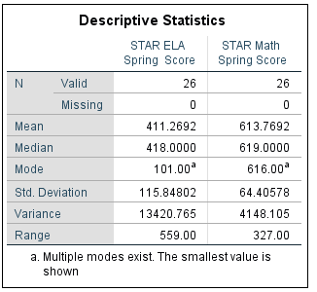
Figure 1: 2018 Spring STAR Reading & Math Assessment Scores

Figure 2, shown below displays the measures of central tendency for the third grade 2018-2019 Fall English Language Arts and Math STAR assessment scores. The mean of the third grade ELA scores is 286, median is 321, and multiple modes are identified with the smallest value of 74. The mean of the third grade Math scores is 499, median is 512, and the mode is 25. The measures of dispersion for the ELA scores are; standard deviation 119, variance 14157 and the range is 533. The measures of dispersion for the Math scores are; standard deviation 75, variance 56178, and the range is 394.
After analyzing this data, I have identified a significant difference of 125 when comparing the fall and spring ELA mean scores. I have also identified a significant difference of 115 when comparing the fall and spring Math mean scores. These statistics have also identified that according to the STAR Reading and Math assessment cut-score equivalents, the sample group of third graders have shown growth when comparing the 2018-2019 STAR Reading & Math, fall and spring assessments.
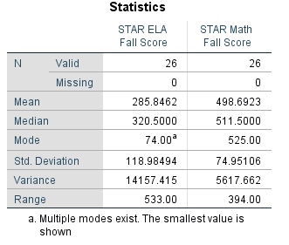
Figure 2: 2018-2019 Fall STAR Reading & Math Assessment Scores
Figures 3, 4, 5, and 6 are histograms that provide a visual representation that there is not a normal distribution between the assessments and during the two times it was administered.
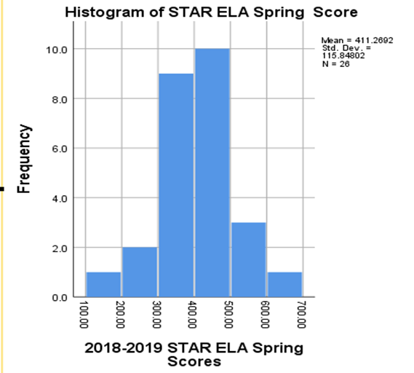
Figure 3: Histogram of 2018-2019 STAR ELA Scores
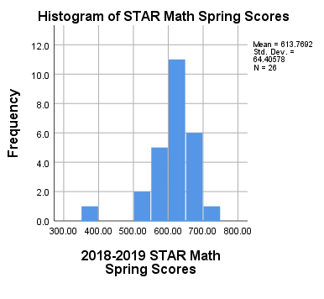
Figure 4: Histogram of 2018-2019 STAR Math Scores

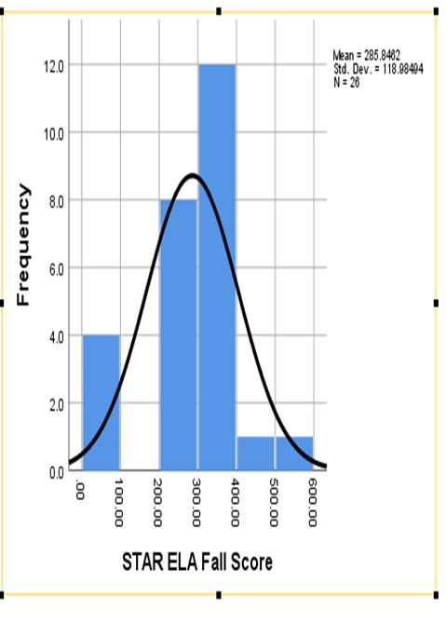
Figure 5: 2018-2019 Histogram of FALL STAR ELA Scores
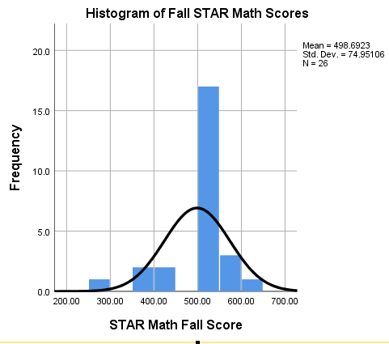
Figure 6: 2018-2019 Histogram of FALL STAR Math Scores

Descriptive Statistics According to Gender
Figures 7 and 8, shown below display the measures of central tendencies for male and female third graders (n = 26, M = 12, F = 14) who took the 2018-2019 Spring English Language Arts and Math STAR assessment scores. The mean of the male third grade ELA scores is 398, median is 378, and multiple modes are identified with the smallest value of 101. The mean of the male third grade Math scores is 623, median is 618, and the mode is 616. The measures of dispersion for the male ELA scores are; standard deviation 154, variance 23677, and the range is 559. The measures of dispersion for the male Math scores are; standard deviation 44, variance 1921, and the range is 168. The mean of the female third grade ELA scores is 423, median is 420, and multiple modes are identified with the smallest value of 286. The mean of the female third grade Math scores is 606, median is 625, and the multiple modes are identified with the smallest value of 397. The measures of dispersion for the female ELA scores are; standard deviation 74, variance 5473, and the range is 308. The measures of dispersion for the female Math scores are; standard deviation 79, variance 6198, and the range is 292.
After analyzing this data, I have determined that the females scored slightly higher than males on the 2018-2019 Spring STAR ELA assessment. There was a mean difference of 25 between the female and male ELA scores. I have also determined that the males scored slightly higher than females on the 2018-2019 Spring STAR Math assessment. There was a mean difference of 17 between the male and female Math scores.
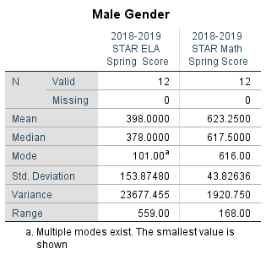
Figure 7: Descriptive Statistics on Males

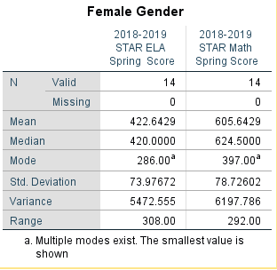
Figure 8: Descriptive Statistics on Females

Independent T-Test Comparing Gender

Independent sample t-tests were conducted to determine if there were significant differences between the 2018-2019 Spring STAR English Language Arts and Math assessment scores according to gender. Figure nine shown below displays the results of the independent sample t-test comparing STAR ELA scores. The figure identifies that n = 12 represents males and n = 14 represents females. There is a slight difference in the STAR ELA scores for females (M = 423, SD = 74) and for males (M = 398, SD = 154) conditions; t (24) = -.533, p = .599. The results indicate that there is a p-value greater than .05 between females and males on the spring STAR ELA scores, therefore we accept the null hypothesis there is no significant difference of 2018-2019 Spring STAR ELA scores between genders.

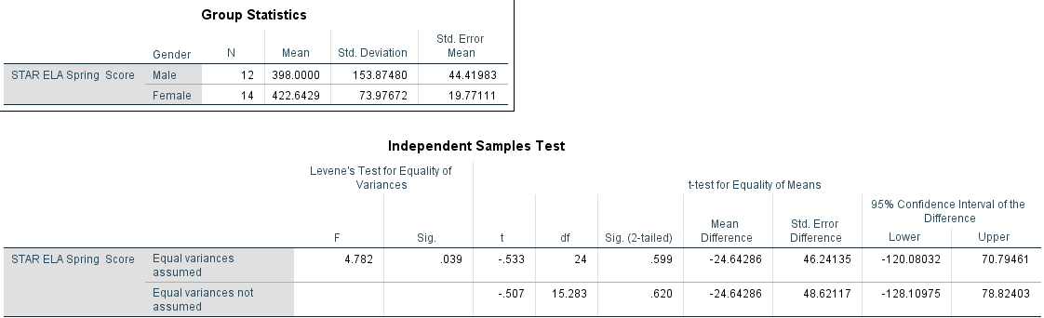
Figure 9: Independent Samples t-test Comparing Differences in Spring ELA Scores by Gender

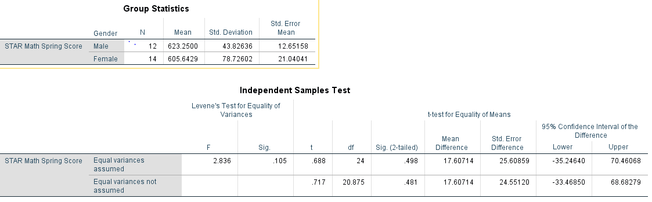
Figure 10: Independent Samples t-test Comparing Differences in Spring Math Scores by Gender

Figure ten shown above displays the results of the independent sample t-test comparing STAR Math scores. The figure identifies that n = 12 represents males and n = 14 represents females. There is a slight difference in the STAR Math scores for males (M = 623, SD = 44) and for females (M = 606, SD = 79) conditions; t (24) = .688, p = .498. The results indicate that there is a p-value greater than .05 between females and males on the spring STAR Math scores, therefore we accept the null hypothesis there is no significant difference of 2018-2019 Spring STAR ELA scores between genders.
Analysis of Variance on Race
An analysis if variance test (ANOVA) was used to compare the differences in race (Hispanics & African Americans) in terms of the 2018-2010 Spring STAR ELA and Math scores. The analysis of variance identifies n = 26 for each STAR assessment. Figure 11 shown below identifies the mean for each race in regards to the STAR ELA and Math scores. In terms of the Spring STAR ELA scores, Hispanics have a mean of 411 and African Americans have a mean score of 412, with an overall score of 411. In terms of the Spring STAR Math scores, Hispanics have a mean of 613 and African Americans have a mean score of 621, with an overall score of 614.
Figure 12 displays the tests of between subjects amongst race. It shows that there is a significant difference in race for the STAR ELA scores, (F (23, 2 = .286, p = .953).

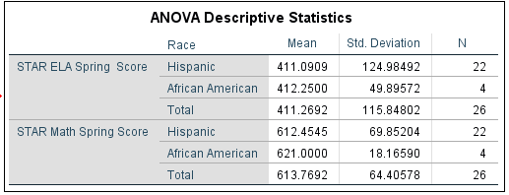
Figure 11: Descriptive Statistics Using ANOVA

ANOVA
STAR ELA Spring Score
 | Sum of Squares | df | Mean Square | F | Sig.
Between Groups | 257359.115 | 23 | 11189.527 | .286 | .953
Within Groups | 78160.000 | 2 | 39080.000
Total | 335519.115 | 25

ANOVA
STAR Math Spring Score
 | Sum of Squares | df | Mean Square | F | Sig.
Between Groups | 103702.615 | 25 | 4148.105 | . | .
Within Groups | .000 | 0 | .
Total | 103702.615 | 25

Figure 12: ANOVA on Race

Conclusion
The results of this study indicated that there was significant difference of 203 when ELA mean scores are compared to Math on the 2018-2019 Spring STAR ELA and Math assessment. This data has also identified that according to the STAR Reading and Math assessment cut-score equivalents, the sample group of third graders are partially meeting expectations in reading and are approaching expectations in Math.
Third grade females scored slightly higher than males on the 2018-2019 Spring STAR ELA assessment and there was a mean difference of 25 between the female and male ELA scores. Males scored slightly higher than females on the 2018-2019 Spring STAR Math assessment. There was a mean difference of 17 between the male and female Math scores. The independent t-test was conducted and it indicated that there is no significant difference of 2018-2019 Spring STAR ELA scores between genders. The analysis of variance test indicated that there is a significant difference in race for the STAR ELA scores, (F (23, 2 = .286, p = .953).
Overall, the analysis of this data allows school districts and individual classrooms to improve teaching and learning towards closing the achievement gaps between race and gender. As we use data to drive instruction, the ultimate goal is to prepare our students with the skills and abilities to compete in the global workforce.

References
K-12 Educational Software Solutions & Learning Analytics. (n.d.). Retrieved April 28, 2019, from https://www.renaissance.com/
Salkind, N. J. (2017). Statistics for people who (think they) hate statistics (6th ed.).SAGE: Thousand Oaks, CA.

Appendix
2018-2019 STAR Renaissance ELA/Math Assessment Fall & Spring Data
Race | Gender | STAR ELA Fall Score | STAR Math Fall Score | STAR ELA Spring Score | STAR Math Spring Score
Hispanic | Male | 333 | 505 | 481 | 676
Hispanic | Male | 466 | 649 | 599 | 724
Hispanic | Female | 287 | 503 | 520 | 630
Hispanic | Female | 8 | 255 | 286 | 397
Hispanic | Male | 74 | 376 | 101 | 616
Hispanic | Female | 250 | 505 | 399 | 611
Hispanic | Male | 275 | 554 | 323 | 605
African American | Female | 334 | 510 | 459 | 642
Hispanic | Male | 323 | 516 | 374 | 619
Hispanic | Male | 393 | 525 | 660 | 578
Hispanic | Female | 541 | 507 | 594 | 662
Hispanic | Female | 261 | 510 | 417 | 665
Hispanic | Female | 375 | 579 | 425 | 671
Hispanic | Male | 229 | 434 | 489 | 616
Hispanic | Female | 241 | 448 | 341 | 525
Hispanic | Female | 366 | 513 | 419 | 668
Hispanic | Male | 337 | 525 | 449 | 646
Hispanic | Male | 74 | 373 | 211 | 556
Hispanic | Female | 237 | 516 | 367 | 581
Hispanic | Male | 295 | 514 | 349 | 620
Hispanic | Female | 333 | 583 | 421 | 689
African American | Male | 95 | 525 | 358 | 625
Hispanic | Female | 330 | 511 | 430 | 589
African America | Male | 318 | 512 | 382 | 598
African American | Female | 332 | 518 | 450 | 619
Hispanic | Female | 325 | 500 | 389 | 530

